Explain this classification report:
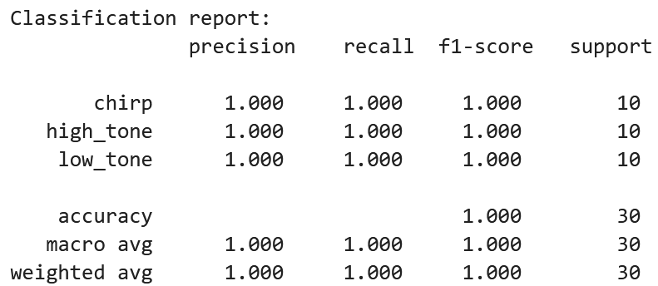
Classification report:
precision recall f1-score support
chirp 1.000 1.000 1.000 10
high_tone 1.000 1.000 1.000 10
low_tone 1.000 1.000 1.000 10
accuracy 1.000 30
macro avg 1.000 1.000 1.000 30
weighted avg 1.000 1.000 1.000 30

Understanding the scikit-learn Classification Report
Your classification report summarizes how well the MFCC-based classifier distinguished the three audio classes: chirp, high_tone, and low_tone.
The report indicates that all 30 test recordings were classified correctly. However, each performance metric measures something different, and understanding those differences becomes important when the classifier starts making mistakes.

1. Understanding each column
Your report:
Class | Precision | Recall | F1-score | Support
chirp | 1.000 | 1.000 | 1.000 | 10
high_tone | 1.000 | 1.000 | 1.000 | 10
low_tone | 1.000 | 1.000 | 1.000 | 10
Accuracy |  |  | 1.000 | 30
Macro avg | 1.000 | 1.000 | 1.000 | 30
Weighted avg | 1.000 | 1.000 | 1.000 | 30
Precision: When the classifier predicts a class, how often is it correct?
Precision for class \(c\) is
\[ \text{Precision}_c=\frac{TP_c}{TP_c+FP_c} \]
where:
- \(TP_c\): True positives — recordings correctly predicted as class \(c\).
- \(FP_c\): False positives — recordings incorrectly predicted as class \(c\).
For example, suppose the classifier predicts that 12 recordings are chirps, but only 9 are actually chirps.
Then
\[ \text{Precision}_{\mathrm{chirp}} =\frac9{12}=0.75. \]
Precision measures how trustworthy a positive prediction is.
In your report, chirp precision is 1.000. This means every recording predicted to be a chirp was actually a chirp.
Recall: Of all recordings belonging to a class, how many did we find?
Recall is
\[ \text{Recall}_c=\frac{TP_c}{TP_c+FN_c} \]
where \(FN_c\) is the number of false negatives: recordings belonging to class \(c\) that were incorrectly assigned to another class.
For example, suppose there are 10 actual chirps but the classifier correctly identifies only 8.
Then
\[ \text{Recall}_{\mathrm{chirp}} =\frac8{10}=0.80. \]
Recall measures how completely the classifier recognizes a particular class.
In your report, chirp recall is 1.000. Therefore, all 10 actual chirps were correctly identified.
F1-score: A balance between precision and recall
The F1-score is the harmonic mean of precision and recall:
\[ \boxed{ F_1= 2\frac{\text{Precision}\cdot\text{Recall}} {\text{Precision}+\text{Recall}} } \]
The F1-score is high only when both precision and recall are high.
For example, if
\[ \text{Precision}=0.75,\qquad \text{Recall}=0.80, \]
then
\[ F_1=2\frac{0.75(0.80)}{0.75+0.80} \approx0.774. \]
In your report, both precision and recall equal 1 for every class, so all F1-scores equal 1.
Support: How many actual examples belong to the class?
Support is simply the number of true examples of a particular class in the test set.
Your report shows:
- 10 actual chirps.
- 10 actual high-frequency tones.
- 10 actual low-frequency tones.
Thus, the total support is
\[ 10+10+10=30. \]
Support is not an accuracy measurement. It tells us how many examples contributed to the evaluation.
2. Understanding the confusion matrix
The classification report can be derived from a confusion matrix.
For your results, the confusion matrix must be:
Confusion matrix — your test results
Correct predictions
Incorrect predictions
30 of 30 correct
Every test recording falls on the diagonal of the confusion matrix. All off-diagonal cells are zero.
Rows represent the actual classes; columns represent predicted classes.
For example, the first row tells us that all 10 actual chirps were predicted as chirps. None were incorrectly classified as high or low tones.
What would happen if there were errors?
Suppose the actual chirps consisted of:
- 8 correctly identified chirps.
- 2 incorrectly classified as high tones.
And suppose 1 actual high tone was incorrectly classified as a chirp.
For the chirp class:
\[ TP=8,\quad FP=1,\quad FN=2. \]
Therefore,
\[ \text{Precision}=\frac89\approx0.889 \]
\[ \text{Recall}=\frac8{10}=0.800 \]
\[ F_1=2\frac{0.889(0.800)}{0.889+0.800} \approx0.842. \]
This demonstrates why precision and recall are different measurements.
3. Accuracy versus macro average versus weighted average
The last three rows summarize performance across the entire classification problem.
Accuracy
Accuracy is the fraction of all examples correctly classified:
\[ \text{Accuracy} = \frac{\text{Number of correct predictions}} {\text{Total test examples}}. \]
For your classifier:
\[ \text{Accuracy}=\frac{30}{30}=1.000. \]
Thus, the test accuracy is 100%.
Macro average
The macro average calculates the arithmetic mean of a metric over all classes, giving each class equal weight.
For example,
\[ \text{Macro Precision} = \frac{P_{\mathrm{chirp}}+ P_{\mathrm{high}}+ P_{\mathrm{low}}}{3}. \]
If the three class precisions were
\[ 0.9,\quad0.8,\quad0.4, \]
the macro precision would be
\[ \frac{0.9+0.8+0.4}{3}=0.7. \]
Every class contributes equally, regardless of how many recordings belong to it.
This is particularly useful when some classes are rare but important.
Weighted average
The weighted average takes class support into account.
For precision,
\[ \text{Weighted Precision} = \frac{\sum_c n_cP_c}{\sum_c n_c} \]
where \(n_c\) is the support for class \(c\).
For example, suppose:
Class | Support | Precision
A | 80 | 0.95
B | 15 | 0.70
C | 5 | 0.40
Then
\[ \text{Weighted Precision} = \frac{80(0.95)+15(0.70)+5(0.40)}{100} =0.885. \]
The macro precision, by comparison, is
\[ \frac{0.95+0.70+0.40}{3} \approx0.683. \]
The weighted average is much higher because class A dominates the dataset.
In your experiment, every class has the same support of 10 recordings. Therefore, macro and weighted averages are identical, even if the individual class scores were different.
4. Interactive example: How one confusion matrix produces the report
You can change the number of correctly classified chirps below and see how the metrics change. For simplicity, the incorrectly classified chirps are assigned to high_tone, with all other predictions assumed correct.
Correctly identified chirps
8 / 10
0
5
10
Chirp precision
1.000
Chirp recall
0.800
Chirp F1
0.889
Class | Precision | Recall | F1
chirp | 1.000 | 0.800 | 0.889
high_tone | 0.833 | 1.000 | 0.909
low_tone | 1.000 | 1.000 | 1.000
Overall accuracy
93.3%
At the initial setting of 8/10, two chirps are misclassified as high tones. Chirp precision remains 1.0 because no other class is incorrectly predicted as a chirp, but chirp recall falls to 0.8.
5. Why the report is not sufficient to establish a good audio classifier
This brings us back to your earlier observation that the model's results seem suspiciously perfect.
The classification report is correctly telling you that the model made no errors on the 30 test recordings. It is not telling you that the classifier will achieve 100% accuracy on all future recordings.
In particular, the report does not establish:
- Whether training and test recordings are representative of actual audio encountered in practice.
- Whether the dataset is sufficiently large.
- Whether the three classes are trivially separable.
- Whether MFCC means and standard deviations are adequate for more challenging sounds.
- Whether the classifier is robust to noise, recording conditions, and signal variability.
For the synthetic dataset used in our project, the low-tone and high-tone classes occupy widely separated frequency ranges. The chirps have distinctly different spectral characteristics.
These class differences are easily captured by MFCC summaries, which explains the perfect classification report.
What I would have students conclude
A strong student interpretation would be:
The classifier achieved 100% accuracy on the 30 held-out test recordings. Precision, recall, and F1-score were all 1.0 for each class, indicating that no classification errors occurred. The macro and weighted averages are also 1.0. However, the dataset contains only three artificially generated and well-separated signal classes, so this result mainly demonstrates that MFCC summary features are sufficient for this simple task. It does not establish that the classifier will generalize to more complex or realistic audio.
That is exactly the distinction I would want senior and graduate DSP students to understand: a perfect classification report can accurately describe an experiment without demonstrating that the model solves a difficult or general problem.

